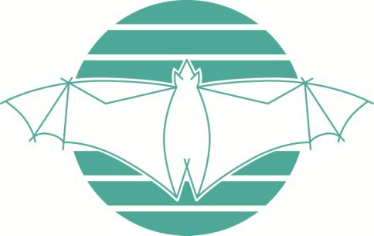
Ku-ring-gai Bat Conservation Society Inc.

MEMBERSHIP APPLICATION

Please note your membership carries a single voting right., please fill out information below.

Title | First name |  | Last name
Name of organisation (if applicable)
Address
Phone |  | Email

Updates covering KBCS activities are emailed to our members quarterly.
Annual membership fee: AU$20.00
(Membership is due and payable 1st July each year - you will receive a reminder)
Donation (Donations are always welcome. Donations over $2 are tax deductible in Australia. A receipt will be emailed to you.)
Total Payment | $

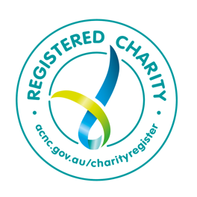

Payment Method

Please note: the account numbers differ depending on whether you are doing a membership only or membership + donation, please see below.

Direct Deposit
Westpac BSB: 032083
Account No:
for membership only: 207854
for membership + donation: 207862
Please tag the payment with your name and email a completed form to web@sydneybats.org.au
Cheque/Money order
Mail completed form & payment to:
Treasurer,
KBCS Inc.
PO Box 607
GORDON NSW 2072
Australia

